Year 6 Art Medium Term Plan Autumn 1 – Drawing/ Henry Moore/ WW2
National Curriculum/P.O.S  Pupils should be taught:  - To create sketchbooks to record their observations and use them to review and revisit ideas  - To improve their mastery of art and design techniques, including drawing, painting and sculpture with a range of materials (for example pencil, charcoal, paint, clay)  - About great artists, architects and designers in history | Skills, knowledge and understanding.  - Select appropriate media and techniques to achieve a specific outcome  - Develop their own style  - Draw for a sustained period of time over a number of sessions  - Use tone in drawings to achieve depth  - Develop drawing with perspective and focal points  - Adapt drawings according to evaluations and discuss further developments  - To know that Henry Moore is a local and significant artist from Leeds  - To know that Henry Moore was a sculptor  - To know that he was commissioned by the UK government to create drawings of people sheltering in the London underground during WW2 as a record of what was happening in history at that time  - To understand that today the legacy of Henry Moore continues, and he is very famous years after his death  - In Leeds city centre there is the Henry Moore Foundation which was set up after his death.
Vocabulary  subtle highlight ethereal gradation  contrasting mid-tone intense  muted varied cross-hatching  dramatic value blurred  tint negative bleach  graduated positive contrast  harsh dapple crisp | Artist/art movement  Artist – local, significant artist Henry Moore. A study of his commissioned drawings in WW2 of people sheltering in the London underground. Link to learning on WW2.
Materials/resources  Sketchbooks, pencils, graphite, chalk, charcoal, oil pastels, chalk pastels, a variety of paper to draw on. | Curriculum links/websites  https://www.tate.org.uk/kids/explore/who-is/who-henry-moore  https://henry-moore.org/discover-and-research/discover-henry-moore/henry-moores-story/the-war-years/  https://www.accessart.org.uk/henry-moores-shelter-drawings/
Lesson 1  What is drawing?  Ask the children to think about what drawing is and how they can draw. Take feedback from the children. What different ways can children make marks on the paper and what different tools can they use to create lines, pattern, texture, marks etc. Explain that drawings can be realistic and look like the object being observed or they can be abstract. What does this mean? Show some images that support this. Look at examples of realistic drawings and abstract. Explain that today’s use of technology allows us to draw using gamepads, ipads etc. Drawings can be colourful or black and white and they are used in many careers – architect, graphic designer, animation, artist, teacher, engineering, technical drawing etc.  Provide the children with a variety of mark making tools – pencils, graphite, chalk, pens, charcoal, graded pencils and give the children time to explore making marks on their sketchbook page using a variety of drawing materials and lines. How do the different tools feel to use? Are some easier to use than others?  Teacher model making marks on sketchbook page using different drawing tools. Allow children plenty of time to explore making marks on their sketchbook page. What happens if the marks are closer together or further apart from each other? Use gallery time to assess and feedback on work done In the lesson.  . 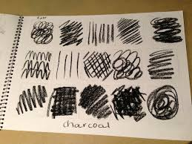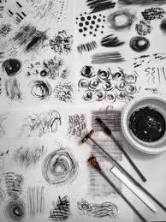  Lesson 3  Who was artist Henry Moore and why is he significant?  Recap learning so far. What can they remember about Henry Moore? Take feedback and explain that they will be learning about his use of drawing as an artist not his sculpture which he is perhaps more widely recognised for. Show a variety of sketches by Henry Moore from across his career not just the war drawings. Allow the children time to look and comment on what they see and notice. Can they comment on his use of marks, line and texture in his drawings?  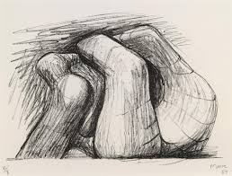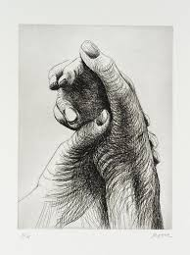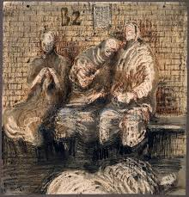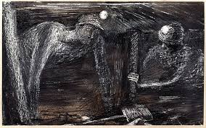  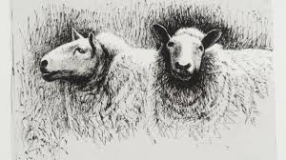  Provide the children with a variety of small images that they can comment on and annotate in their sketchbooks.  Lesson 5  What did Henry Moore’s drawings look like during WW2 at the time of the Blitz?  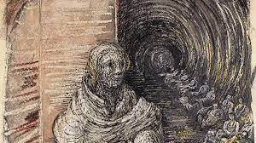  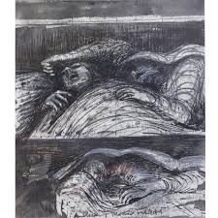  Recap learning so far. Look at a selection of Henry Moore’s drawings of people sheltering in the underground during the Blitz. What do the children notice? How have these drawings been created? What drawing materials did he use to create the drawings? Explain that he used cheap, wax crayons to create marks and lines to form the shapes of people sheltering and then he used a simple background wash of ink over the top to create a dark background and sense of atmosphere.  Ask the children to get into pairs. Using their sketchbook they will create a figure drawing of each other. One child will sit for 5/10 minutes and model while the other child draws. The children will use simple wax crayons to create their drawing of their partner using lines and marks. They will then swap over so that they each get a turn at drawing. Use a dark , watercolour back ground wash to paint over the drawing like Henry Moore. If time allows repeat the drawing session using different positions and models so that the children will have a series of drawings on their sketchbook page.  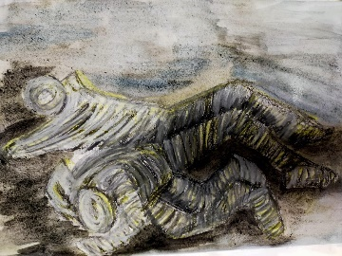  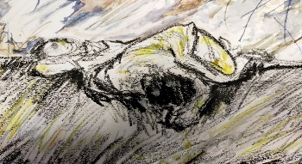 | Lesson 2  Who was artist Henry Moore?  https://www.tate.org.uk/kids/explore/who-is/who-henry-moore  Display the artists name on the IWB. Does anyone know who Henry Moore was and why we are learning about him? Show images of his work. What do the children notice? What can they say about his work? Explain that he is an artist from Leeds who was born in Yorkshire and has now died. He has left behind a huge amount of work for generations to enjoy which include sculptures, drawings, paintings and maquettes. We will be looking at some images of his variety of work and making annotations and drawings in sketchbooks. Children can use provided images to stick on their sketchbook pages.  Teacher model how to create a sketchbook page. It should have key vocabulary, drawings and provided images on the page. Children should be encouraged to use a variety of drawing materials to record their ideas including – pencil, graphite, chalk, charcoal, pen etc.  Use gallery time to assess the sketchbook pages. What can the children say about the pages?  Lesson 4  What did Henry Moore’s drawings look like during WW2 at the time of the Blitz?  Recap learning so far and explain that they will be looking at how Henry Moore created a series of drawings during WW2. He was commissioned by the UK government to capture the conditions for civilians sheltering during the Blitz in the London underground. Show children images of what London looked like during WW2. How do the images make them feel? How could that feeling be captured through drawing? Provide the children with some black and white images of the Blitz and ask the children to create small sketches on their sketchbook pages using a variety of drawing materials – pencil, graphite, chalk, charcoal, pen etc. Try and get a sense of atmosphere in their drawings. How can they create dark and light areas in their drawings using line and marks? The closer the lines are together, the darker the area of the drawing will be. Children explore mark making using provided Blitz images.  .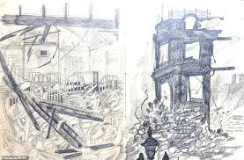  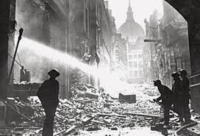  . 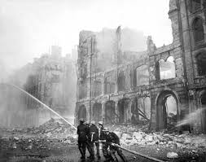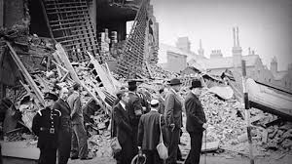  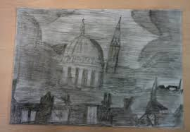  Lesson 6  What did Henry Moore’s drawings look like during WW2 at the time of the Blitz?  Recap learning so far. Use gallery time to look at drawings from previous lesson and take feedback from the children.  Explain that in the lesson today they will try and create a sense of atmosphere in their drawings. To enable this, we will use the dark space corridor in school which is like the dark underground tube stations in London. Again, the children will have the opportunity to draw children in seated and laying positions. The corridor is dark. How will they show this through their drawings and use of background wash? Can you see all the seated figures? Ensure children have wax crayons and a watercolour tin of paints and a brush before moving to the space corridor. Children can record people positioned differently, individually or in small groups. Return to the art room and place sketchbook drawings on the tables to allow children to look at them in full light.  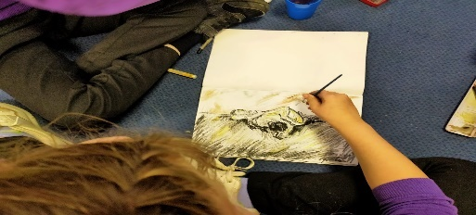  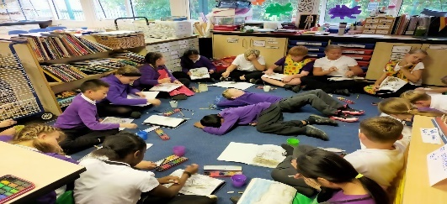  Allow children time to look at each other’s drawings. Do they have a sense of atmosphere? How do they make them feel when they look at the drawings? Compare to Henry Moore’s drawings. Do they think it was easy for him to draw in the underground tube station?  Can they comment on their own work and that of others?

