Year 5 Art Medium Term Plan Autumn 1 – Sculpture/ Mayan masks
National Curriculum/P.O.S.  - To create sketchbooks to record their observations and use them to review and revisit ideas  - To improve their mastery of art and design techniques, including drawing, painting and sculpture with a range of materials (for example pencil, charcoal, paint, clay)  - About great artists, architects and designers in history | Skills, knowledge and understanding.  - Develop an understanding of different ways of finishing work (e.g. glaze, paint, polish, varnish)  - Understand that a range of media can be selected (due to their properties) for different purposes  Independently recognise problems and adapt work when necessary – taking inspiration from other sculptors  - To know and understand that the Mayan civilisation was an ancient civilisation  - To know where the Mayan civilisation came from  - To know and understand how the Mayan civilisation celebrated significant events  - To understand the importance of the celebration masks in Mayan culture  - To use clay to create a 3d Mayan mask for a specific purpose  - To use scoring and finishing techniques to create a replica Mayan mask using clay  - To use simple rolled out 3d shapes (spheres, cylinders) to create other shapes for their final clay, Mayan mask
Vocabulary  angular proportioned coiled positive space  bulbous curvaceous aerial view  geometric elongated scale  regular organic conical  irregular precise form  tapering perspective mechanical  sweeping enlarge negative space  Mayans, culture, clay, 2d, 3d, scoring, flat, texture, pattern, malleable, slip, join. | Artist/art movement  The Mayans – celebration masks  Research, draw and make a 3D Mayan mask using clay for a specific event/purpose.
Materials/resources  Sketchbooks, Mayan images and information, clay, clay tools, clay boards, cloths, water containers, paints, PVA glue (varnish). | Curriculum links/websites  https://www.bbc.co.uk/bitesize/topics/zq6svcw  https://www.youtube.com/watch?v=9GsSWzfCBFc
Lesson 1  What is sculpture and how can they be made?  Ask the children to think about sculpture and what it means to them. Use talk partners to discuss and feedback. How is sculpture different from other art forms? Explain that sculpture is 3d and other art forms drawing, painting etc are 2d.  How can sculpture be made?  Show images of sculpture from around the world. Discuss the materials used to make sculpture and the different sizes/scales of sculpture. Ask the children to create a sculpture research page in their sketchbooks. Encourage them to note down their thoughts and ideas about the different sculptures seen. Do they have a favourite? Why? They can use their own drawings, annotations and small provided images on their sketchbook page. Can they think of any sculptors they might remember from prior learning? Barbara Hepworth (y1), Andy Goldsworthy(y2), Alexander Calder(y3), Nikki De Saint Phalle(y4) etc.  Encourage the children to use a variety of drawing materials to record their ideas about sculpture.  Lesson 3  Who were the Mayans and how did they celebrate?  Recap learning so far. What can the children recall? Take feedback. Explain that they will be learning about a specific part of Mayan culture through art and sculpture. They will learn about the use of celebration masks to mark significant events in the lives of the ancient Mayan people.  Mayan death mask of Pakal the great.  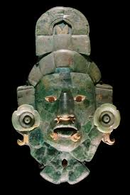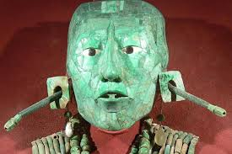  Mayan battle masks: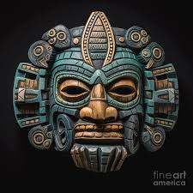  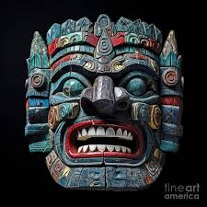  Maya god of the sun:  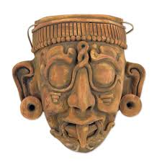  Look at images of different Mayan masks with the children and the different uses of the masks. Allow children time to look at images of different masks and create drawings in their sketchbooks. They can annotate their drawings and label. Encourage use of colour and give the children the opportunity to look carefully at the features of the masks. | Lesson 2  Who were the Mayans?  What do children know about the Mayan culture?  Allow time for discussion and feedback. Share:  https://www.bbc.co.uk/bitesize/topics/zq6svcw/articles/zqv6msg  Encourage the children to read through some of the text and share the short video clips. Teacher scribe on board key info provided from clips. Look at a map together to locate the Mayan civilisation and compare to UK. Children will create a Mayan research page in their sketchbook using a variety of materials. The page must include drawings, key information, dates, places etc, and any found images of the Mayan culture that they may want to stick on their page. Encourage the children to be creative as to how they combine and place their information. They can use a variety of drawing materials to do so.  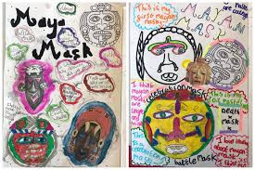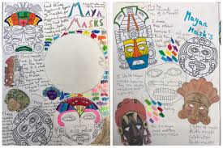  Lesson 4  Who were the Mayans and how did they celebrate?  In this lesson the children will start to take ideas from their sketchbooks and images gathered so far to create a Mayan mask design of their own in their sketchbook. They will need to decide whether the mask is a celebration mask – marriage, birth etc, a battle mask (designed to intimidate the enemy) or a death mask. What features will the mask have? Eyes, nose, mouth, ears, tongue, headdress? Encourage the children to take inspiration from masks looked at so far.  Using an A4 sketchbook page the children will need to create a design for their Mayan mask. They will create the mask using clay and clay techniques. It will need to be a bold and confident design. Notice the features on the traditional Mayan masks are big and stand out on the mask. At this point the children will need to consider their use of colour. Children to draw their design on their sketchbook page. This is the design that they will work from. They will need to consider how they will create the features using clay. What tools can they use to add texture and fine details?  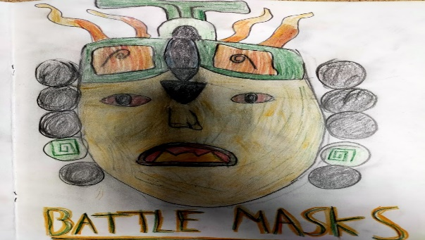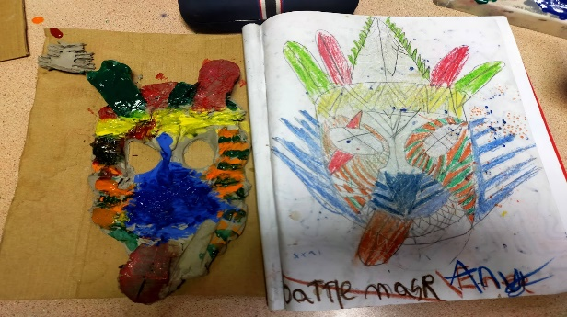  Lessons 5/6/7  What did ancient Mayan masks look like and what were they used for?  Using the Mayan mask design from their sketchbooks the children will begin to create their Mayan masks using clay and joining techniques. Show the children how to roll out a piece of clay using wooden guides and a rolling pin. Ensure the clay is 1 cm thick and of an even thickness throughout. Do not let the children roll the clay thinly as this will crack and break when it dries out. Teacher model how to soften the clay using hands and shape into simple spheres and sausages. These basic shapes will form the basis of the additional features that they add to the mask – nose, eyes, mouth, ears, tongue etc. Can the children remember how to join two pieces of clay? Check prior learning. They will need to score the surface of the clay which involves them making lines one way and then lines another way, a little bit like a hashtag. Teacher model how to do this. They will also need to add a small amount of water to the scored area of the clay. When clay and water combine you have ‘slip’ which is like a glue. Once the two surfaces of clay have been joined using scoring and slip the children will just need to seal the join using water and their small finger. If they don’t score the clay surfaces, they will not join when the clay dries out. Once they have added the features to their Mayan clay mask, they can think about adding texture to the surface. What marks can they make and what tools could they use? We have clay tools but things like toothbrushes, cocktail sticks, plastic forks etc make interesting texture marks. Ensure everything is joined and sealed together well and that details and texture have been added to the mask before allowing it to dry. Ensure the children keep the clay they are not working with damp so it is still malleable for them to use. Take photos of finished Mayan masks and stick into sketchbooks. In the next lesson the children will finish their Mayan mask by adding colour using paint. Teacher model how to do this. Each area of the mask will need several coats of paint to allow the paint to dry bright. When the paint is dry a coat of PVA glue can be added which acts as a varnish. Children can evaluate the process of making their Mayan mask next to the photo in their sketchbook. Think about the overall completed mask, what skills/techniques did they learn/use? Was anything difficult? Would they create it differently if they had the chance to make a second mask?  