Year 4 Art Medium Term Plan Autumn 1 - Collage
National Curriculum/P.O.S  - to use a range of materials creatively to design and make products  - to use drawing, painting and sculpture to develop and share their ideas, experiences and imagination  - to develop a wide range of art and design techniques in using colour, pattern, texture, line, shape, form and space  - about the work of a range of artists, craft makers and designers, describing the differences and similarities between different practices and disciplines, and making links to their own work. | Skills, knowledge and understanding.  - Develops experience in embellishing, using more advanced joining techniques  - Experiment with a range of collage techniques such as tearing, overlapping and layering to create collaged images  - To know and understand who the Anglo Saxons were  - To understand that they were very skilled at making art and jewellery  - To understand that many ancient Anglo Saxon artefacts have been dug out of the ground and have been discovered accidentally.
Vocabulary  Anglo Saxons, relics, artefacts, collage, layering, cut, shape, precise, embellish, pattern, texture, detail, symmetry, template. | Artist/art movement  Anglo Saxon relics/artefacts/jewellery
Materials/resources  Cardboard, scissors, glue, paint, posca pens, sharpie pens, string, sketchbooks, pencils, graphite, colouring pencils, images of Anglo Saxon relics – crosses, brooches, bracelets. | Curriculum links/websites  https://www.bbc.co.uk/bitesize/articles/zq2m6sg  https://www.bbc.co.uk/teach/school-radio/articles/zhtdd6f  https://www.ashmolean.org/learning-resource-anglo-saxons
Lesson 1  What is collage and who were the Anglo Saxons?  Recap the children’s understanding of collage. What does this word mean? Discuss and feedback. Can they recall any collage work they have done previously? Explain that collage is where materials/images/paper/fabric can be cut up and layered to make a final composition. Show the children examples of collage work by different artists.  Explain that they will be using collage skills and techniques to learn about the Anglo Saxons. Does anyone know who the Anglo Saxons were? Whereabouts in history do they sit on the timeline? Who were they and why are we learning about them through art?  Share information about the Anglo Saxons and encourage the children to take notes. Watch the BBC clip. Provide the children with some Anglo Saxon images of what life was like for them. Allow children time to create a research page in their sketchbook about the Anglo Saxons. Encourage the children to use their own drawings, cut out images, key words and information on their sketchbook page.  Lesson 3  What did Anglo Saxon relics look like and how can I use collage to recreate a relic?  Recap learning so far. Explain that using images provided and their research from their sketchbooks the children will begin to create their own Anglo Saxon relics using cardboard to create the different layers of their object. Explain they will be making a 3d product with depth, pattern and detail. They will need to create a design for either a piece of AS jewellery or a cross. They will start with the base layer and work up from that using smaller, designed, cut out pieces of cardboard.  Show the children some examples of work from previous year 4 Anglo Saxon relics. Once the cardboard structure of the object is made they will then use other materials – paint, posca pens, sharpies etc to add finishing details and embellishments. Children can have a choice of whether they make a cross, a pendant or a brooch.  Children will begin to create the base layer of their collaged object and build up the different layers using cardboard pieces that have been drawn and cut out. Teacher model how to do this and refer to designs of jewellery pieces from sketchbooks and images used so far. Explain that they will need to take care drawing and cutting out their pieces. Lots of the ancient relics had symmetry. Show the children how to create a shape using cardboard and then use that shape as a template to recreate duplicates of the shape that will create good symmetry in their final piece as opposed to cutting out random pieces of different sizes.  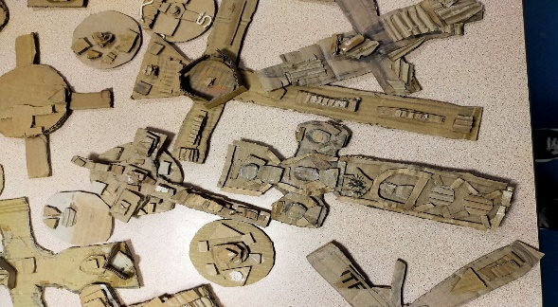  Lesson 5  What details can I add to my finished collaged piece to ensure it looks authentic?  The children will continue to work on their AS relic. They will use paint to create a base colour on their relic. Allow drying time and then use posca pens to create areas of highlight on the object. Explain that the light will hit the object on one side so the highlight will be on one side of the object. The shadows/dark areas will be on the opposite side of the object away from where the light hits the object. Teacher model how to create areas of highlight and shadow on the object. Adding highlights and shadow areas to the objects creates a sense of the object being 3 dimensional. | Lesson 2  What did the Anglo Saxons leave behind?  Recap learning from the previous week. Discuss how the Anglo Saxons were clever people with a huge skills set. We know this from things that have been left behind and unearthed from the ground. Discuss the discovery of artefacts found at Sutton Hoo in Suffolk just before the outbreak of war in 1939.  Look at images from this find. Explain that the artefacts were found in a burial chamber alongside a member of the royal family. It is today the most significant Anglo Saxon find due to what was found. Look at the jewellery, crosses and relics. What do the children notice? Discuss and feedback.  Provide the children with images of Anglo Saxon jewellery and crosses found at Sutton Hoo. Give the children time to look closely and observe the images. Use their sketchbooks to record the different relics, patterns and details. Children should be encouraged to use a variety of different drawing materials. Children create sketchbook pages showing different jewellery items and relics. Encourage them to annotate the drawings.  Lesson 4  What did Anglo Saxon relics look like and how can I use collage to recreate a relic?  Children continue to create their 3d Anglo Saxon relic using cardboard building up the layers in their cross, brooch or pendant. Look at how the Anglo Saxons used pattern in their pieces. How can this be recreated using materials like cardboard, string etc?  Explain that when they are happy with their collaged object everything will need gluing down securely to hold the pieces in place. Encourage the children to think about their use of colour. How will they make their object look authentic? What colours will they use? How can they add shadows and highlights to their finished pieces to give the object a sense of it being 3d?  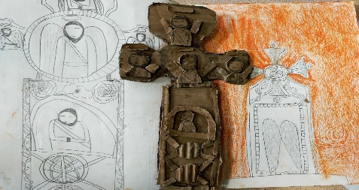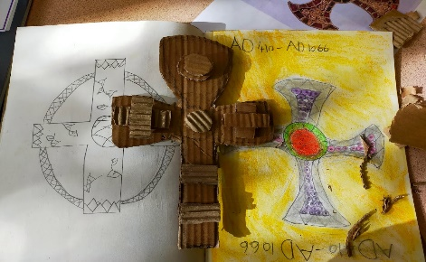  Lesson 6  What details can I add to my finished collaged piece to ensure it looks authentic?  In this final session give the children time to finalise their object/s. Ensure all collaged pieces are well stuck down and that the piece follows their ideas from their sketchbook images. Ensure they have painted the cardboard collage well and used posca pens, sharpies, chalk etc to create highlights and shadows. Take a photograph of their finished piece and give the children time to assess the process and the final piece. Aare they happy with it? Does it look authentic? Could they have added anything different to improve it and make it better?  Children to write brief comments/thoughts on the process and final piece in their sketchbooks alongside a photograph of the finished 3d relic.  Finally, how do they compare to the real AS artefacts? Give the children gallery time to observe and look at other children’s work. How do they make them feel when looking at them? Do they look realistic?

