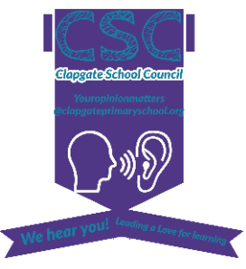
School Council Minutes 9.2.22

Lots of deliberation has taken place to think about what the school wants from our school council and how they will have an impact on the children and community. The school council’s focus for the remainder of the year will primarily be promoting CAS and planning and supporting the Queen’s Jubilee celebrations.

Creating Active Schools (CAS)
Ways to showcase class keeping active
Activity cards for classrooms – pick an activity to do every 30 mins
Parents in – PE, outdoor learning (scavenger hunt), obstacle course on a trim trail
‘Calm time’ mindfulness activity
Yoga solar dome
Quick games to play (some of these may take too long for its purpose) or to incorporate in active learning:
Monopoly, Marco Polo, Apple Pie, Murder Mystery, Colouring, Create a game, Uno, Hide and Seek, Sardines, Tig, Man hunt, Ludo, Duck duck goose, Dominoes, Real hangman (if you say the wrong letter you’re out), Blind Man’s Bluff, Real risk, Role Play, Charades

Queen’s Jubilee – 70 years - Celebrations
Party for school – ideas:
Bouncy castles, bouncy castle slides, slides, tea party (afternoon), face paint, different types of games: races, crown toss, crafts, pin the crown on the Queen.
Design cupcake/cookies
Learning ideas
Learn about the Queen and the monarchy
Queen Quiz – quizzes for KS1, KS2
Send the Queen a card (writing lesson)
Andy Worhal Queen painting/print (art)
Plant a tree to commemorate the Queen’s Jubilee

Notebooks – school council to be provided with an exercise book to make notes.

Thursday eve club to go ahead after half term.

